|  |
| --- |
| Computing Technology Inquiry Project |
| Assignment 1 Report  COS10026  Hans Yee Jia Syn | 102780414 |
| Bachelor of Computer Science (Honours) |
|  |
|  |

School of Engineering, Computer Science

Swinburne University of Technology

Sarawak Campus

# TABLE OF CONTENTS

TABLE OF CONTENTS 1

1.0 Introduction 2

2.0 Website Content 3

2.1 Sitemap 3

2.2 Blog (Activities & Event Page) 3

2.2.1 Current Activities Page 5

2.2.2 Coming Soon Page 5

2.2.3 Past Activities Page 6

3.0 Website Style 8

3.1 Blog (Activities & Event Pages) 8

3.1.1 Blog 8

3.1.2 Coming Soon 9

3.1.3 Current Activity 11

3.1.4 Past Activity 12

4.0 Conclusion 13

4.1 Future Improvements and Recommendations: 13

# Introduction

The *Brew & Go* website was developed as a marketing-oriented platform with two core objectives: to act as a digital storefront that promotes the brand and its offerings, and to provide existing and potential customers with an engaging and informative user experience. It serves both as a presentation tool for marketing purposes and as a self-introduction for the Brew & Go brand.

For existing customers, the site allows members to sign in, browse the latest drinks and promotions, collect points, and stay updated with current activities and events. For new visitors, it introduces the brand’s identity, culture, and product philosophy in an accessible and visually appealing format.

This project holds deep personal meaning to us. It represents the most time, energy, and creative effort We’ve ever invested in any assignment so far. From structuring the content and developing forms to fine-tuning the CSS animations and layout details — every line of code reflects hours of dedication. While I acknowledge that the submission deadline marks the current limit, I view this site as one of my most complete and polished works to date.

This report will provide a breakdown of the website’s structure and purpose, an overview of the design and styling techniques used, and a review of the key features and enhancements implemented throughout the project.

# Website Content

## Sitemap

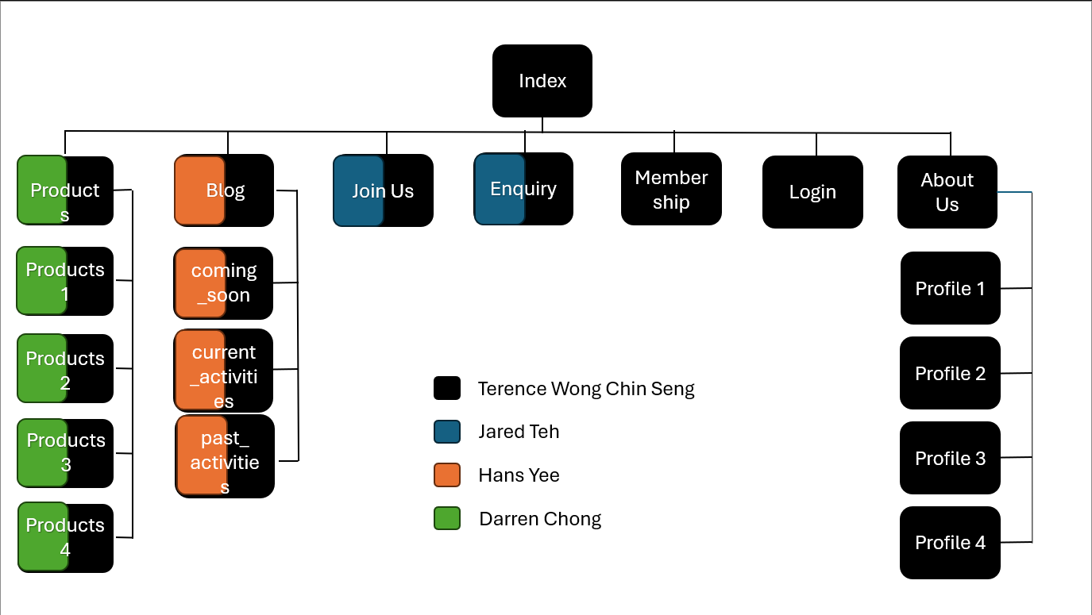

## Blog (Activities & Event Page)

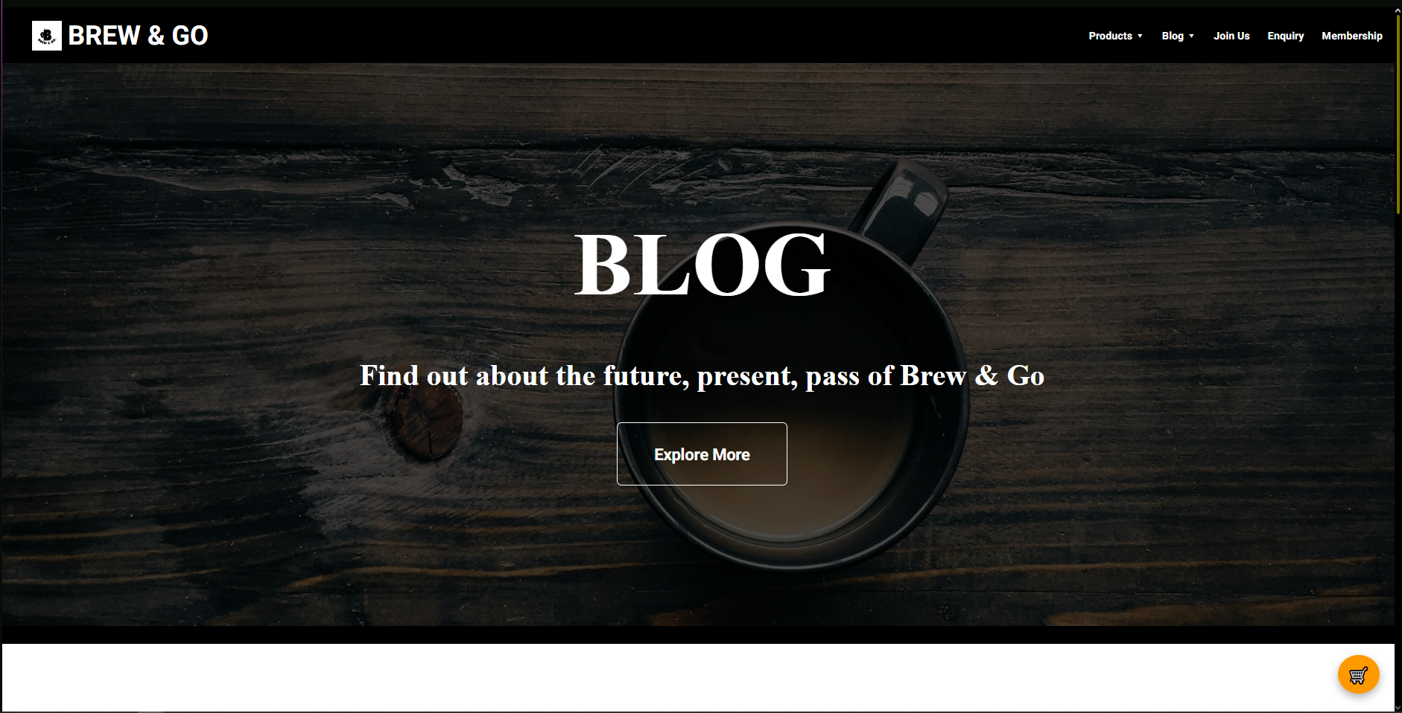

The blog.html page acts as a content hub that connects users to the three main activity subpages: coming_soon.html, current.html, and past_activities.html. Its purpose is to provide a summary and gateway for users interested in Brew & Go’s events, promotions, and ongoing campaigns. The layout of the blog page includes a **hero title section** introducing the blog and event categories, a **clickable slideshow** that cycles through highlights from recent and upcoming activities. Each slide is interactive, containing an image with a brief hover-over text description and a direct link to the corresponding activity page

This slideshow was implemented using HTML and CSS without JavaScript, with smooth image transitions and visual effects to engage the user. Text elements fade in or animate on hover to offer additional context, such as event names, dates, and teaser summaries. For example, images related to upcoming events link to coming_soon.html, while community recaps route users to past_activities.html.

From a semantic standpoint, the page uses <section>, <figure>, and <a> tags correctly, and media elements are optimized for responsive viewing. This page enhances user interaction by creating a dynamic gateway between promotional materials and actual content, encouraging visitors to explore Brew & Go’s brand beyond products.

The layout of the blog page includes:

* A **hero title section** introducing the blog and event categories
* A **clickable slideshow** that cycles through highlights from recent and upcoming activities
* Each slide is interactive, containing an image with a brief hover-over text description and a direct link to the corresponding activity page

This slideshow was implemented using HTML and CSS without JavaScript, with smooth image transitions and visual effects to engage the user. Text elements fade in or animate on hover to offer additional context, such as event names, dates, and teaser summaries. For example, images related to upcoming events link to coming_soon.html, while community recaps route users to past_activities.html.

From a semantic standpoint, the page uses <section>, <figure>, and <a> tags correctly, and media elements are optimized for responsive viewing. This page enhances user interaction by creating a dynamic gateway between promotional materials and actual content, encouraging visitors to explore Brew & Go’s brand beyond products.

### Current Activities Page

The current_activity.html page displays live or ongoing promotions. It includes an eye-catching event card featuring a high-quality product image, a description of the limited-time promotion, and an external link to Brew & Go’s Facebook page for real-time updates. This setup enhances interactivity and drives traffic toward social platforms while keeping customers informed about active deals

### Coming Soon Page

On the coming_soon.html page, upcoming events are highlighted in a single large section that combines an image, a short description, and a promotional video. The structure uses <figure>, <video>, and an <aside> panel to offer details like setup dates, hands-on activities, and location information. This modular and multimedia-driven format keeps visitors informed about what’s next while aligning with the overall aesthetic of the site.

### Past Activities Page

Lastly, past_activity.html compiles historical events and memorable moments, each presented in alternating left-right alignment for visual rhythm. Every activity is paired with its respective poster image, descriptive paragraph, and time-frame data presented within stylized cards. External links to Facebook posts and Instagram images allow users to revisit these events beyond the static webpage, offering archival transparency and celebrating Brew & Go's engagement history.

All blog-related pages feature consistent navigation, styling, and footer sections, maintaining design cohesion across the site. Together, these pages demonstrate how Brew & Go communicates brand personality and community involvement while integrating marketing goals within an engaging digital experience.

# Website Style

## Blog (Activities & Event Pages)

### Blog

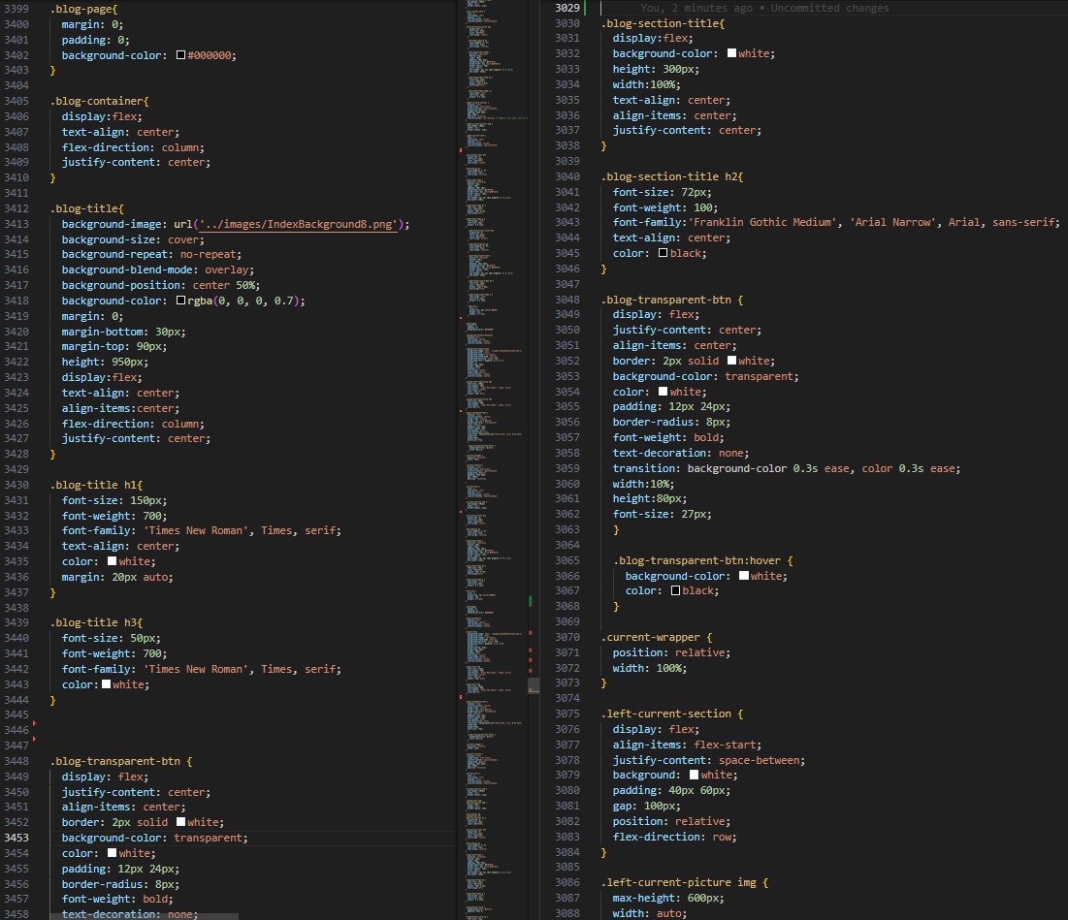

The blog-container wraps the main blog content and introduces the page with a visually strong title section (blog-title). It includes the <h1> for “BLOG”, a subheading <h3> for the slogan, and a button styled with blog-transparent-btn to lead users to the activities section below.

**▸ Current Activities Section**

Identified by the ID current-activities, this part uses a blog-section-title to highlight the section. A line-title-wrapper provides a horizontal line for visual separation. The top-row wraps current-wrapper, which contains current-section—this displays a current promotional image (current-picture), related text (current-info), and a date range (blog-time-frame). Together, these inform users of the latest event details clearly and responsively.

**▸ Coming Soon & Past Activities Overview**

This lower segment is grouped into a bottom-row, which includes a coming-soon-box with hoverable image and overlay caption (coming-caption) leading to the Coming Soon page. Adjacent to it is past-activities, which contains a past-slideshow that cycles through multiple past-slide divs with event posters and date captions.

### Coming Soon

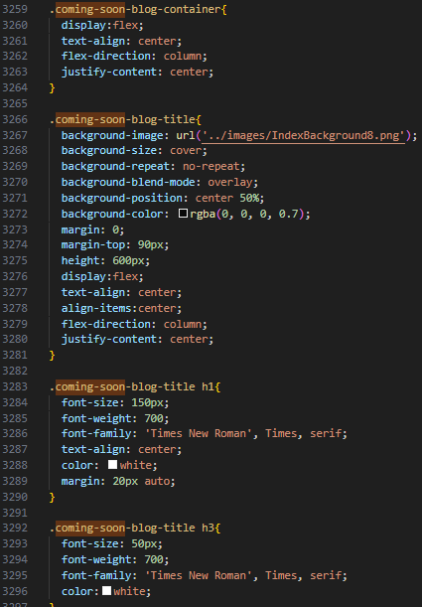

The content begins with coming-soon-blog-container, setting up a clear identity for the page. Within it, coming-soon-blog-title provides a large welcoming heading (Upcoming Events) and a smaller subtitle.

▸ Highlighted Event Block

The top-row structure is reused here for layout. Inside, current-wrapper and current-section hold an event image (current-picture) linked to the Instagram post, a text block (current-info) filled with event details, and a blog-time-frame that displays a date range. These components mirror the layout of the blog page for consistency, while the content itself is centered on upcoming events like Mini Seni Kita.

### Current Activity

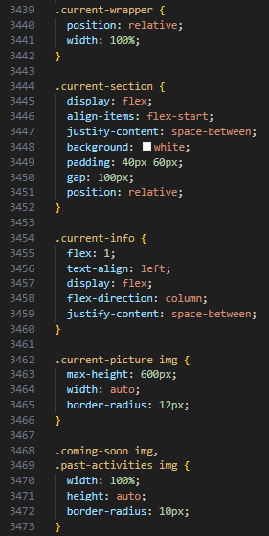

Interestingly, this page uses the exact same structure and class names as coming_soon.html. The same coming-soon-blog-container, coming-soon-blog-title, top-row, current-wrapper, and current-section layout patterns are used. The content is different, emphasizing present-time events or ongoing promotions.

▸ Informative Text

The textual content in current-info uses paragraphs to describe the activity, including its context, partners, and timing. The reuse of components allows easy maintenance and a uniform look across events.

### Past Activity

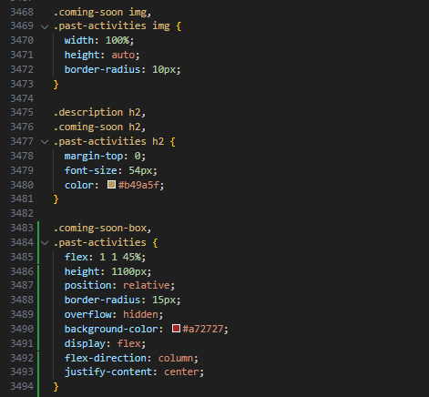

Like current_activity.html, this file uses coming-soon-blog-container, and all its nested components like top-row, current-wrapper, current-section, and blog-time-frame are reused. However, the actual imagery and text are focused on historical events or completed campaigns.

▸ Layout Strategy

The consistent use of current-section even for past content is a strategic choice that simplifies design. The only changing elements are the media (images) and paragraph content, while the layout remains completely uniform.

# Conclusion

This project involved the development of a multi-page website for **Brew & Go**, showcasing products, membership programs, ongoing activities, and interactive content. The site was built using HTML and CSS only, following semantic and responsive design principles. Pages such as index.html, product1~4.html, joinus.html, enquiry.html, membership.html, and profile1.html were carefully structured to ensure consistency in branding and usability. Key features implemented include a mobile-responsive navigation bar, animated carousel, collapsible content cards, embedded Google Maps, membership flip cards, and various hover-based enhancements.

Throughout the development process, we gained hands-on experience with layout design, media responsiveness, semantic structuring, and user interface interactivity—all while working within the limitations of HTML and CSS. This exercise not only strengthened our frontend design skills but also reinforced the importance of accessibility and user experience design.

## Future Improvements and Recommendations:

1. **Cleaner and More Modular Codebase**:

Refactoring the code to improve naming conventions, segment reusable styles, and reduce redundancy would make the project more scalable and easier for future collaboration.

1. **JavaScript Integration**

With JavaScript, we can greatly enhance interactivity. For example, making the embedded map clickable with real-time location filtering or allowing users to interact with dynamic form validation and animations would elevate the user experience.

1. **Expanded Media Queries for Diverse Devices**

While the current responsive layout works well for common screen sizes, introducing more @media breakpoints (e.g., for tablets, ultra-wide monitors, or foldable phones) would ensure an even more seamless experience across a wider range of devices.

1. **Backend Implementation**:

Introducing a backend (e.g., using PHP, Node.js, or Firebase) could allow for persistent data storage, user authentication, dynamic product listings, and admin content management—transforming this static website into a fully functional web application.

1. **Framework Usage**:

Future iterations could benefit from adopting frontend frameworks like Bootstrap or Tailwind CSS for faster styling, or even React.js or Laravel for modular component-based development to enhance maintainability and performance.

Looking back, I feel there’s still much more that could be achieved. This project was a meaningful step forward, and I’m proud of what we’ve built—but I also look forward to future opportunities where I can push the boundaries even further, refine my skills, and deliver something even better.